DAY 3

Import 'package:flutter/material.dart';

void main() => runApp(MyApp());

class MyApp extends StatelessWidget {

@override

Widget build(BuildContext context) {

return MaterialApp(

home: Scaffold(

appBar: AppBar(

title: Text('Drawer Example'),

),

drawer: Drawer(

child: ListView(

padding: EdgeInsets.zero,

children: <Widget>[

DrawerHeader(

decoration: BoxDecoration(

color: Colors.blue,

),

child: Text(

'Drawer Header',

style: TextStyle(

color: Colors.white,

fontSize: 24,

),

),

),

ListTile(

leading: Icon(Icons.home),

title: Text('Home'),

onTap: () => Navigator.pop(context),

),

ListTile(

leading: Icon(Icons.edit),

title: Text('Edit'),

onTap: () {

// Action for Edit can be added here

Navigator.pop(context);

},

),

ListTile(

leading: Icon(Icons.settings),

title: Text('Settings'),

onTap: () => Navigator.pop(context),

),

],

),

),

body: Center(

child: Text('Drawer Example App'),

),

),

);

}

}

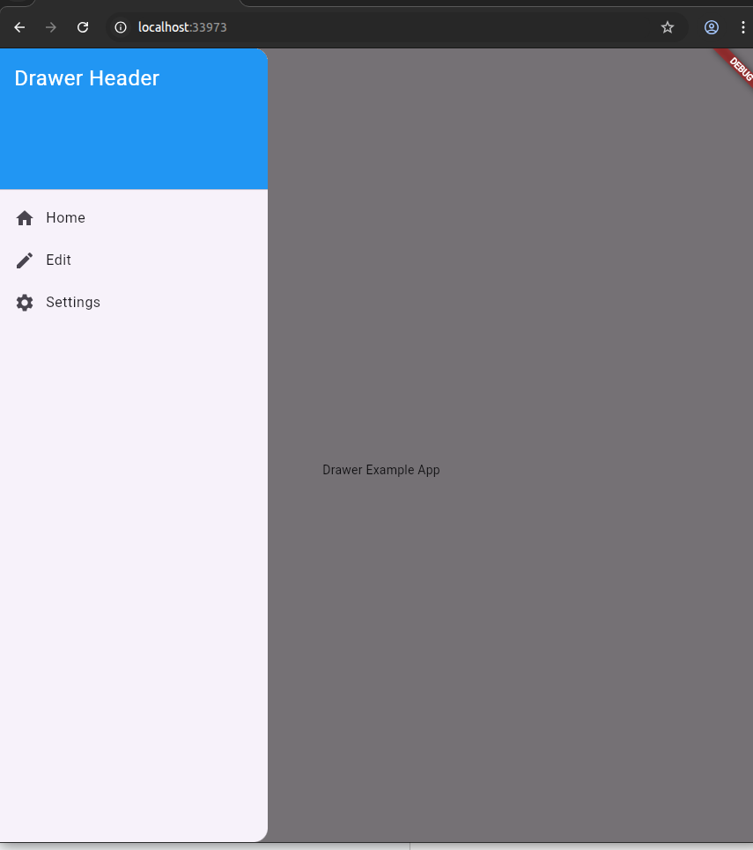

import 'package:flutter/material.dart';

void main() => runApp(MyApp());

class MyApp extends StatelessWidget {

@override

Widget build(BuildContext context) {

return MaterialApp(

home: Scaffold(

appBar: AppBar(

title: Text('FloatingActionButton Example'),

),

body: Center(

child: Text('Press the button below!'),

),

floatingActionButton: FloatingActionButton(

onPressed: () {

// Action to perform when the button is pressed

print('Button Pressed!');

},

child: Icon(Icons.add),

backgroundColor: const Color.fromARGB(218, 243, 33, 44),

),

),

);

}

}

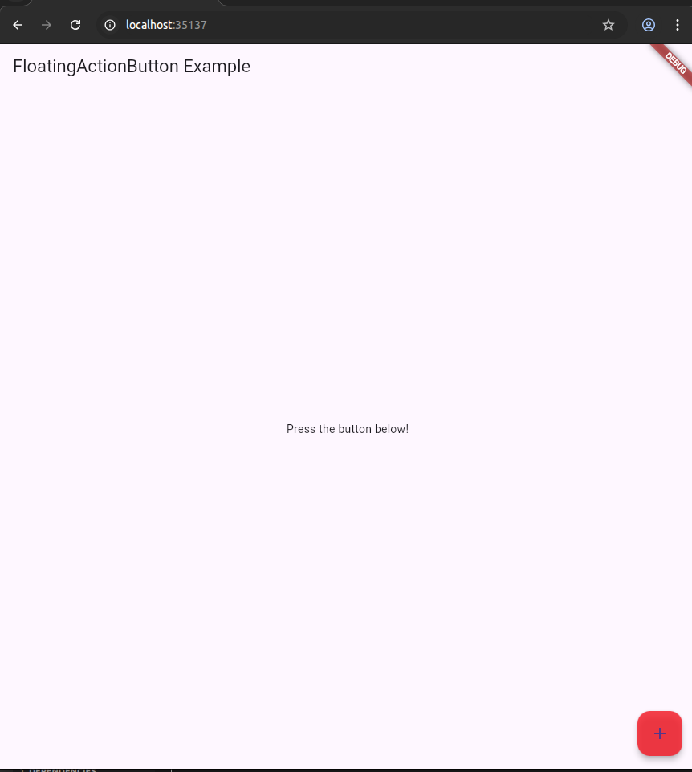

import 'package:flutter/material.dart';

void main() => runApp(MyApp());

class MyApp extends StatelessWidget {

@override

Widget build(BuildContext context) {

return MaterialApp(

home: Scaffold(

appBar: AppBar(

title: Text('Container Example'),

),

body: Center(

child: Container(

padding: EdgeInsets.all(35),

margin: EdgeInsets.all(20),

alignment: Alignment.bottomRight,

transform: Matrix4.rotationZ(0.1),

child: Text(

"Hello! I am in the container widget",

style: TextStyle(fontSize: 25),

),

),

),

),

);

}

}

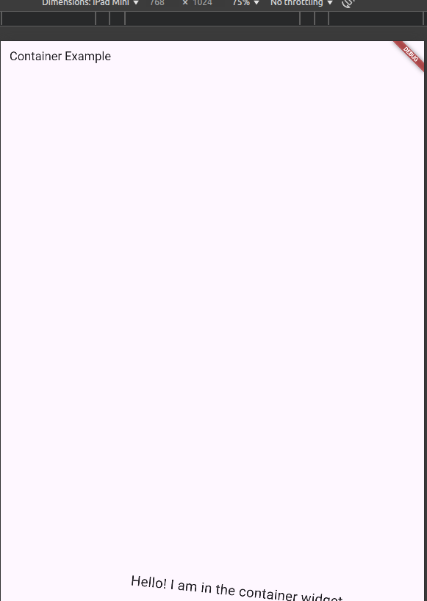

import 'package:flutter/material.dart';

void main() => runApp(MyApp());

class MyApp extends StatelessWidget {

@override

Widget build(BuildContext context) {

return MaterialApp(

home: Scaffold(

appBar: AppBar(

title: Text('Constraints Example'),

),

body: Center(

child: Container(

constraints: BoxConstraints(

minWidth: 100,

maxWidth: 200,

minHeight: 100,

maxHeight: 200,

),

color: Colors.blue,

child: Center(

child: Text(

'Constrained Container',

style: TextStyle(

color: Colors.white,

fontSize: 18,

),

),

),

),

),

),

);

}

}

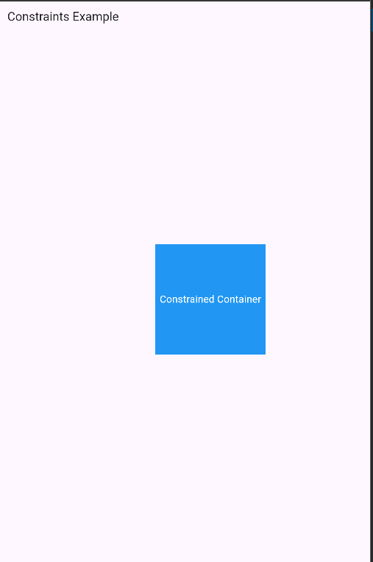

DAY 3:

ASSIGNMENT 2:

FIRST:

import 'package:flutter/material.dart';

void main() {

runApp(RowWidgetExample());

}

class RowWidgetExample extends StatelessWidget {

@override

Widget build(BuildContext context) {

return MaterialApp(

home: Scaffold(

appBar: AppBar(

title: Text('Row Widget Example'),

),

body: Center(

child: Row(

mainAxisAlignment: MainAxisAlignment.center,

children: <Widget>[

Container(

width: 50,

height: 50,

color: Colors.brown,

),

SizedBox(width: 10), // Spacing between containers

Container(

width: 50,

height: 50,

color: Colors.green,

),

SizedBox(width: 10), // Spacing between containers

Container(

width: 50,

height: 50,

color: Colors.blue,

),

],

),

),

),

);

}

}

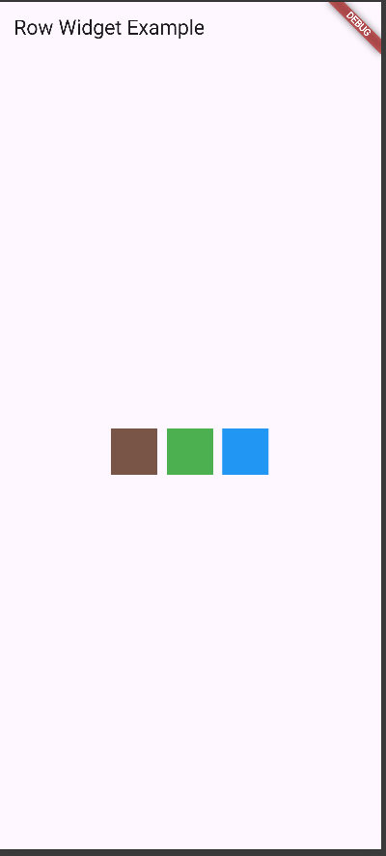

SECOND:

import 'package:flutter/material.dart';

void main() {

runApp(RamaiahChairmanApp());

}

class RamaiahChairmanApp extends StatelessWidget {

@override

Widget build(BuildContext context) {

return MaterialApp(

debugShowCheckedModeBanner: false,

home: RamaiahProfileScreen(),

);

}

}

class RamaiahProfileScreen extends StatelessWidget {

@override

Widget build(BuildContext context) {

return Scaffold(

appBar: AppBar(

title: Text('Ramaiah Chairman Profile'),

backgroundColor: Colors.blue,

),

body: Center(

child: Card(

margin: EdgeInsets.all(20),

elevation: 4,

child: Padding(

padding: EdgeInsets.symmetric(horizontal: 20, vertical: 30),

child: Column(

mainAxisSize: MainAxisSize.min,

children: [

CircleAvatar(

radius: 50,

backgroundImage: AssetImage('/home/cselab3/Downloads/ramaiah1.jpg’),

),

SizedBox(height: 20),

Text(

'Dr. M.S. Ramaiah',

style: TextStyle(

fontSize: 20,

fontWeight: FontWeight.bold,

),

),

Text(

'Founder Chairman',

style: TextStyle(

fontSize: 16,

color: Colors.grey[600],

),

),

SizedBox(height: 20),

Text(

'Mathikere Sampangi Ramaiah was born on 20 April 1922, in Madhugiri to Sampangappa and Narasamma.',

style: TextStyle(fontSize: 14),

textAlign: TextAlign.center,

),

],

),

),

),

),

);

}

}

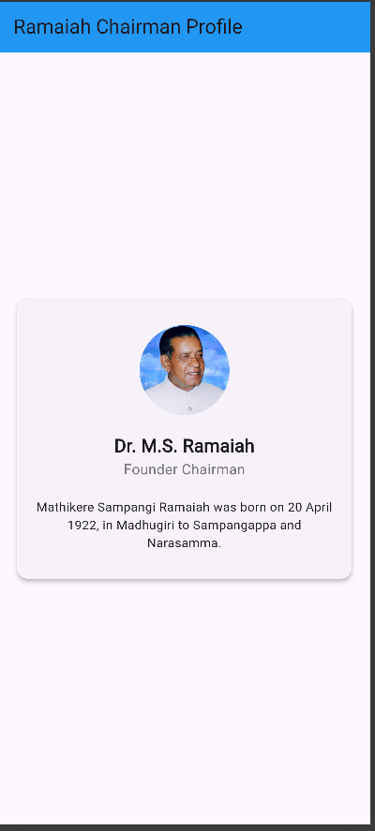

THIRD:

import 'package:flutter/material.dart';

void main() => runApp(MyApp());

class MyApp extends StatefulWidget {

@override

_MyAppState createState() => _MyAppState();

}

class _MyAppState extends State<MyApp> {

String _displayText = '';

void _handleButtonClick() {

setState(() {

_displayText = "refusing to restart...\n"

"Initializing in 65s;\n"

"Button Clicked";

});

}

@override

Widget build(BuildContext context) {

return MaterialApp(

title: 'TextButton Example',

home: Scaffold(

appBar: AppBar(

title: Text('Exercise-03'),

),

body: Padding(

padding: const EdgeInsets.all(32.0),

child: Row(

crossAxisAlignment: CrossAxisAlignment.start,

children: [

// Left column with button

Container(

width: 200,

decoration: BoxDecoration(

border: Border.all(),

),

child: Column(

mainAxisAlignment: MainAxisAlignment.start,

children: [

Container(

width: double.infinity,

color: Colors.blue[200],

padding: EdgeInsets.all(8),

child: Text('TextButton Example'),

),

SizedBox(height: 50),

TextButton(

onPressed: _handleButtonClick,

child: Text('Click Me'),

),

],

),

),

SizedBox(width: 50),

// Right side text display

if (_displayText.isNotEmpty)

Container(

padding: EdgeInsets.all(10),

color: Colors.black87,

child: Text(

_displayText,

style: TextStyle(

color: Colors.white,

fontFamily: 'Courier',

),

),

),

],

),

),

),

);

}

}

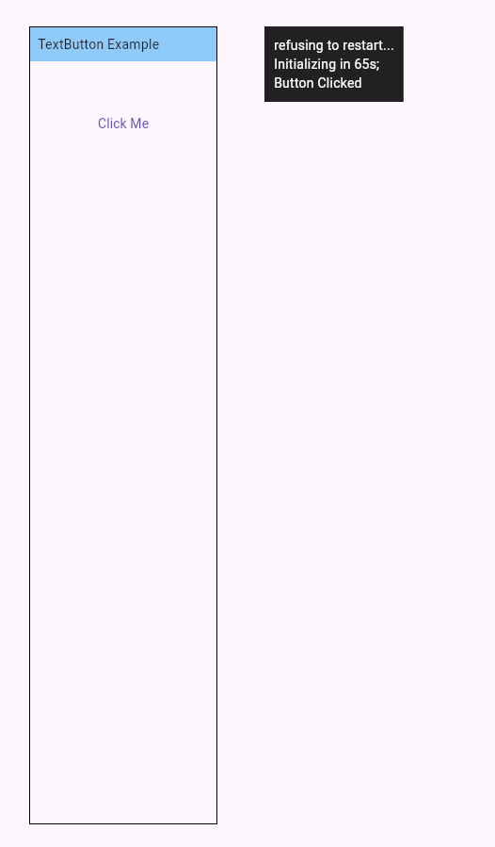

FOURTH:

import 'package:flutter/material.dart';

void main() {

runApp(MyApp());

}

class MyApp extends StatelessWidget {

@override

Widget build(BuildContext context) {

return MaterialApp(

title: 'ElevatedButton Example',

theme: ThemeData(

primarySwatch: Colors.blue,

),

home: ElevatedButtonExample(),

debugShowCheckedModeBanner: false,

);

}

}

class ElevatedButtonExample extends StatefulWidget {

@override

_ElevatedButtonExampleState createState() => _ElevatedButtonExampleState();

}

class _ElevatedButtonExampleState extends State<ElevatedButtonExample> {

bool showTerminal = false;

@override

Widget build(BuildContext context) {

return Scaffold(

backgroundColor: Colors.grey[100],

body: Row(

children: [

// Left panel - Main content

Container(

width: 400,

height: double.infinity,

color: Colors.white,

child: Column(

children: [

// Header with blue background

Container(

width: double.infinity,

padding: EdgeInsets.symmetric(horizontal: 16, vertical: 12),

decoration: BoxDecoration(

gradient: LinearGradient(

colors: [Colors.blue[600]!, Colors.teal[400]!],

begin: Alignment.centerLeft,

end: Alignment.centerRight,

),

),

child: Row(

children: [

// Bullet point

Container(

width: 6,

height: 6,

decoration: BoxDecoration(

color: Colors.white,

shape: BoxShape.circle,

),

margin: EdgeInsets.only(right: 12),

),

Text(

'ElevatedButton Example',

style: TextStyle(

color: Colors.white,

fontSize: 16,

fontWeight: FontWeight.w500,

),

),

Spacer(),

// Small icon in corner

Container(

width: 20,

height: 20,

decoration: BoxDecoration(

color: Colors.white.withOpacity(0.3),

borderRadius: BorderRadius.circular(3),

),

child: Icon(

Icons.code,

size: 12,

color: Colors.white,

),

),

],

),

),

// Content area

Expanded(

child: Padding(

padding: EdgeInsets.all(24),

child: Column(

crossAxisAlignment: CrossAxisAlignment.start,

children: [

SizedBox(height: 150),

// Click Me button

ElevatedButton(

onPressed: () {

setState(() {

showTerminal = true;

});

},

style: ElevatedButton.styleFrom(

backgroundColor: Colors.blue[600],

foregroundColor: Colors.white,

padding: EdgeInsets.symmetric(horizontal: 24, vertical: 12),

shape: RoundedRectangleBorder(

borderRadius: BorderRadius.circular(6),

),

elevation: 2,

),

child: Text(

'Click Me',

style: TextStyle(

fontSize: 14,

fontWeight: FontWeight.w500,

),

),

),

Spacer(),

],

),

),

),

],

),

),

// Right panel - Terminal output

Expanded(

child: Container(

color: Colors.grey[100],

child: showTerminal

? Container(

margin: EdgeInsets.all(20),

padding: EdgeInsets.all(16),

decoration: BoxDecoration(

color: Colors.black87,

borderRadius: BorderRadius.circular(4),

boxShadow: [

BoxShadow(

color: Colors.black26,

blurRadius: 8,

offset: Offset(0, 4),

),

],

),

child: Column(

crossAxisAlignment: CrossAxisAlignment.start,

mainAxisSize: MainAxisSize.min,

children: [

Text(

'A Dart VM Service on Chrome is available at: http://127.0.0',

style: TextStyle(

color: Colors.lightGreen,

fontSize: 12,

fontFamily: 'monospace',

),

),

SizedBox(height: 4),

Text(

'The Flutter DevTools debugger and profiler on Chrome is ava',

style: TextStyle(

color: Colors.lightGreen,

fontSize: 12,

fontFamily: 'monospace',

),

),

SizedBox(height: 4),

Text(

'Button Clicked!',

style: TextStyle(

color: Colors.white,

fontSize: 12,

fontFamily: 'monospace',

),

),

SizedBox(height: 8),

// Cursor

Container(

width: 8,

height: 14,

color: Colors.lightGreen,

),

],

),

)

: SizedBox.shrink(),

),

),

],

),

);

}

}

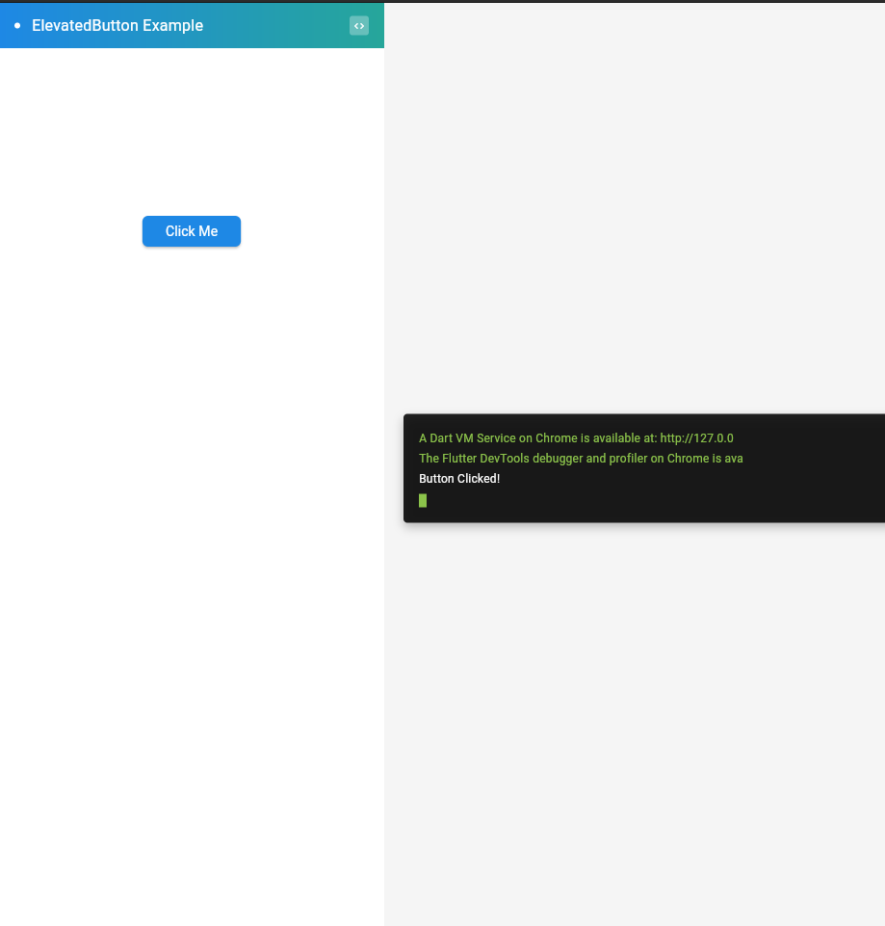

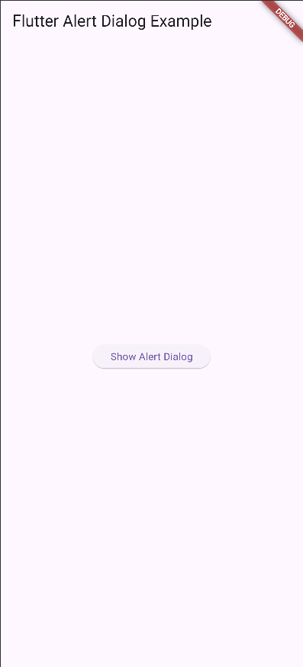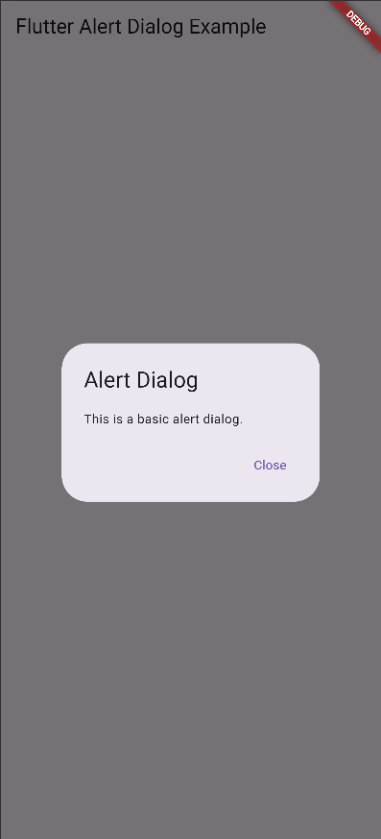

mport 'package:flutter/material.dart';

void main() => runApp(MyApp());

class MyApp extends StatelessWidget {

@override

Widget build(BuildContext context) {

return MaterialApp(

home: MyHomePage(),

);

}

}

class MyHomePage extends StatelessWidget {

@override

Widget build(BuildContext context) {

return Scaffold(

appBar: AppBar(

title: Text("Flutter Icons Example"),

),

body: Center(

child: Column(

mainAxisAlignment: MainAxisAlignment.center,

children: <Widget>[

Icon(

Icons.star,

size: 100.0,

color: Colors.yellow,

),

Text("Star Icon", style: TextStyle(fontSize: 20.0)),

SizedBox(height: 20.0),

Icon(

Icons.favorite,

size: 100.0,

color: Colors.red,

),

Text("Favorite Icon", style: TextStyle(fontSize: 20.0)),

SizedBox(height: 20.0),

Icon(

Icons.local_florist,

size: 100.0,

color: Colors.green,

),

Text("Florist Icon", style: TextStyle(fontSize: 20.0)),

],

),

),

);

}

}

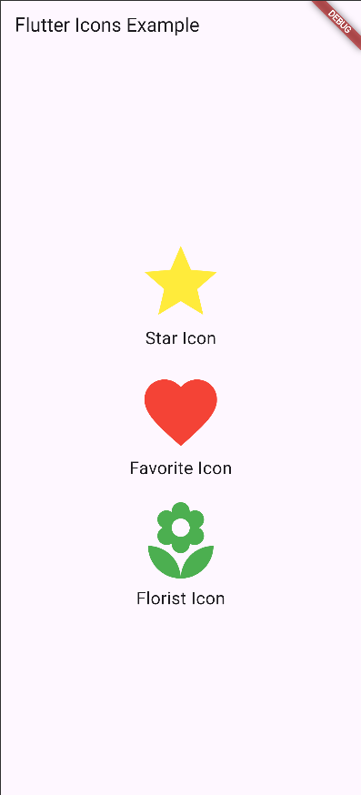

mport 'package:flutter/material.dart';

void main() => runApp(MyApp());

class MyApp extends StatelessWidget {

@override

Widget build(BuildContext context) {

return MaterialApp(

home: MyHomePage(),

);

}

}

class MyHomePage extends StatelessWidget {

final List<String> items = [

'Item 1',

'Item 2',

'Item 3',

'Item 4',

'Item 5',

];

@override

Widget build(BuildContext context) {

return Scaffold(

appBar: AppBar(

title: Text("Flutter List Example"),

),

body: ListView.builder(

itemCount: items.length,

itemBuilder: (BuildContext context, int index) {

return ListTile(

title: Text(items[index]),

);

},

),

);

}

}

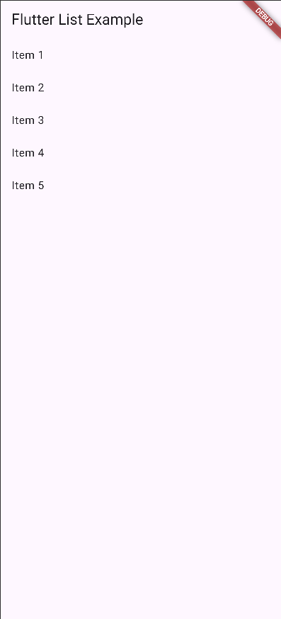

import 'package:flutter/material.dart';

void main() {

runApp(MyApp());

}

class MyApp extends StatelessWidget {

@override

Widget build(BuildContext context) {

return MaterialApp(

home: MyHomePage(),

);

}

}

class MyHomePage extends StatelessWidget {

void showToast(BuildContext context) {

ScaffoldMessenger.of(context).showSnackBar(

SnackBar(

content: Text('Hello, Flutter Toast!'),

duration: Duration(seconds: 2),

),

);

}

@override

Widget build(BuildContext context) {

return Scaffold(

appBar: AppBar(

title: Text('Flutter Toast Example'),

),

body: Center(

child: ElevatedButton(

onPressed: () => showToast(context),

child: Text('Show Toast'),

),

),

);

}

}

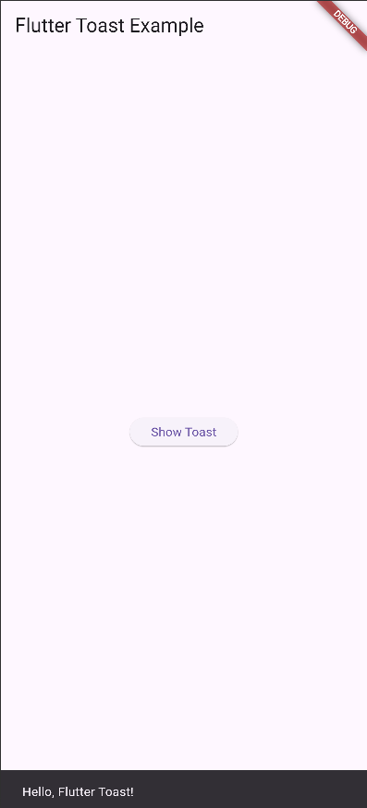

import 'package:flutter/material.dart';

void main() {

runApp(MyApp());

}

class MyApp extends StatelessWidget {

@override

Widget build(BuildContext context) {

return MaterialApp(

theme: ThemeData(

scaffoldBackgroundColor: Colors.black, // Set background color to black

primaryColor: Colors.yellow, // Set text color to yellow

),

home: MyHomePage(),

);

}

}

class MyHomePage extends StatelessWidget {

@override

Widget build(BuildContext context) {

return Scaffold(

appBar: AppBar(

title: Text('Flutter Theme Example'),

),

body: Center(

child: Text(

'Welcome to Flutter Themes',

style: TextStyle(

fontSize: 24,

color: Colors.yellow, // Set text color explicitly

),

),

),

);

}

}

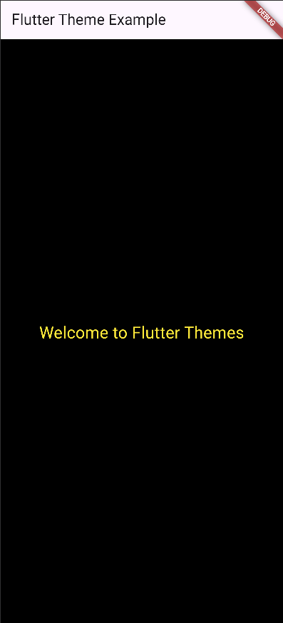

mport 'package:flutter/material.dart';

import 'package:fl_chart/fl_chart.dart';

void main() {

runApp(MyApp());

}

class MyApp extends StatelessWidget {

@override

Widget build(BuildContext context) {

return MaterialApp(

home: MyHomePage(),

);

}

}

class MyHomePage extends StatelessWidget {

@override

Widget build(BuildContext context) {

return Scaffold(

appBar: AppBar(

title: Text('Flutter Pie Chart Demo'),

),

body: Center(

child: PieChart(

PieChartData(

sections: [

PieChartSectionData(

color: Colors.blue,

value: 30,

title: 'Category A',

),

PieChartSectionData(

color: Colors.green,

value: 40,

title: 'Category B',

),

PieChartSectionData(

color: Colors.orange,

value: 20,

title: 'Category C',

),

PieChartSectionData(

color: Colors.red,

value: 10,

title: 'Category D',

),

],

),

),

),

);

}

}

